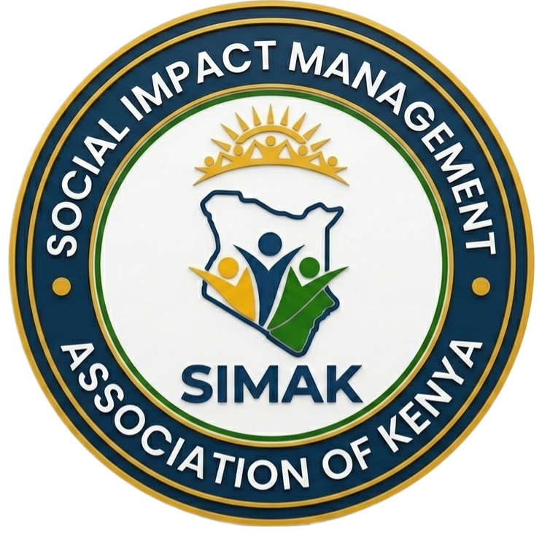
SOCIAL IMPACT MANAGEMENT ASSOCIATION OF KENYA (SIMAK)
Muthaiga Business Center – Pangani | Off Thika Road – 2nd Flr
Tel: +254789174626 | Email: info@simakenya.org
Website: www.simakenya.org

MEMBERSHIP REGISTRATION APPLICATION FORM
Instructions: Fill the details below and send together with your CV and copy of ID to: info@simakenya.org
Name
Phone number
Email: Address
National ID number
Organization
Professional background
Highest level of education Attained
Years of experience in SRIA
Category of membership
Current physical address
Professional Requirements and registration fee.
Lead Expert | - Must have a degree in social science, preferably in the following disciplines: Sociology, Social Work, Anthropology, Community Development, Socio- Economics, Gender Studies (or any other related field in social science as determined by the council on a case by case basis).  - Has attained a minimum of 10 years in Social Impact Management practice.  - Provide evidence of preparation or implementation of at least 5 Environmental and Social Impact Assessments, Resettlement Action Plan or Social Assessment.  - Make a verbal presentation of a project report the prospective member has completed in the last 5 (five) years before a panel of peers who are members of SIMAK.  - Has practiced as an associate expert for 5 years. | 10,000/=
Associate Expert | - Minimum of an undergraduate degree in social science, preferably in the following disciplines: Sociology, Social Work, Anthropology, Community Development, Social Economics, Gender Studies (or any other related social sciences as determined by the council on a case by case basis) or Minimum of an undergraduate degree in other disciplines and completion of the prescribed Social Impact Management courses from an accredited institution.  - Has attained a minimum of 5 years in Social Impact Management practice.  - Produce evidence of participation in the preparation or implementation of at least two Social Impact Management reports  - Make a verbal presentation of a project report that the prospective member participated in and which has been completed in the last 5 (five) years before a panel of peers who are members of SIMAK. | 5000/=
Graduate Member | - Undergraduate degree in social sciences or a discipline required in the practice of SIA, OR  - Diploma in sociology (or any other social sciences) and 3 years Social Impact Management experience  - Completed the prescribed Social Impact Management courses from an accredited institution. | 2000/=
Corporate membership | - Consulting firms registered in Kenya or within other jurisdictions with grounded practice in Social Impact Management fields. Such firms must have at least one lead expert as a director and at least two members of staff qualified to be associate experts. | 50,000/=
Additional requirements
- CV
- Copy of ID

